Convolution Layer

Convolution layer is the first layer to extract features from an input image. By learning image features using a small square of input data, the convolutional layer preserves the relationship between pixels. It is a mathematical operation which takes two inputs such as

* The dimension of the image matrix is **h×w×d**.
* The dimension of the filter is **fh×fw×d**.
* The dimension of the output is **(h-fh+1)×(w-fw+1)×1**.

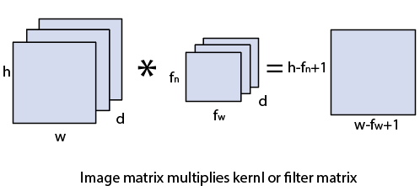

Let's start with consideration a 5*5 image whose pixel values are 0, 1, and filter matrix 3*3 as:

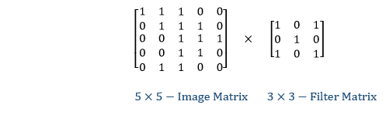

The convolution of 5*5 image matrix multiplies with 3*3 filter matrix is called "**Features Map**" and show as an output.

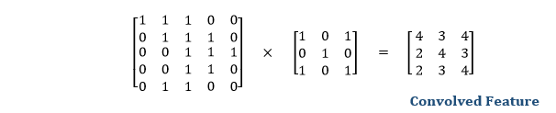

Convolution of an image with different filters can perform an operation such as blur, sharpen, and edge detection by applying filters.

Strides

Stride is the number of pixels which are shift over the input matrix. When the stride is equaled to 1, then we move the filters to 1 pixel at a time and similarly, if the stride is equaled to 2, then we move the filters to 2 pixels at a time. The following figure shows that the convolution would work with a stride of 2.

